FIRE ASSEMBLY POINT
- LOCATED AT THE FURTHEST POINT OF THE VILLAGE HALL CARPARK.
Fire Action
ANY PERSON DISCOVERING A FIRE SHOULD:
- SOUND THE ALARM TO OTHERS BY SHOUTING “FIRE, FIRE, FIRE”, AND EXIT THE BUILDING TO THE ACCEMBLY POINT BY ONE OF THE FIRE EXITS.
- AFTER EXITING THE BUILDING DIAL 999 TO CALL THE FIRE BRIGADE.
- ATTACK THE FIRE IF POSSIBLE, USING THE CORRECT APPLIANCES PROVIDED.

ON HEARING THE FIRE ALARM
LEAVE THE BUILDING BY ONE OF THE FIRE EXITS AND HEAD TO THE ASSEMBLY POINT.
CLOSE ALL DOORS BEHIND YOU
DO NOT TAKE RISKS
DO NOT RETURN TO THE BUILDING FOR ANY REASON UNTIL AUTHROISED TO DO SO.
Please see Next page for Fire Extinguisher Locations and Fire Exits.
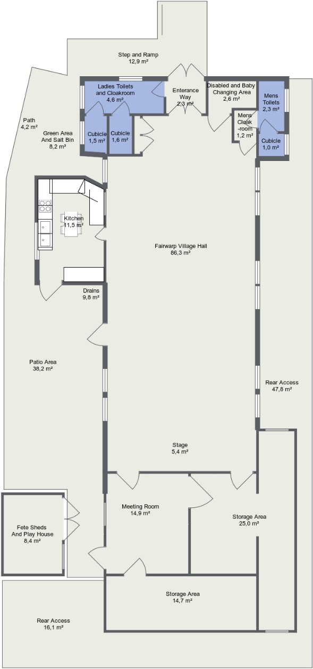
Fire Exit
Fire Exit
Fire Exit

